



2nd Quarter Newsletter April – June 2020

 Hello Southpoint Owners,

I hope this message finds you and your family safe and well, especially during these very trying times of dealing with Covid-19.

This beautiful picture was taken of the full super moon in March, right before our world as we knew it, completely changed…



Per Roger Koop, the following improvements have recently been made at Southpoint –

1. Phil Danley, Jeff and Roger installed 12 new yellow parking bollards in the garage to replace the bent and damaged original ones.

2. Jeff has given all of the Adirondack chairs and tables a fresh coat of paint.

3. New garage light fixtures have been purchased and will be installed as the construction progresses.

4. Master Craft will replace all of the fire hose cabinets.

5. One of the roof top ventilators which pull air up and out from the unit dryers has been replaced.

6. The stairwell doors and new locksets have been ordered and will be installed by the contractor. The new doors are fire rated fiberglass with a tan gel coat color and should never need painting.

Once projects are underway, Roger will post weekly engineering reports to go with the ongoing reports located for your viewing pleasure on the Southpoint website under the Documents tab. You will also see photographs of the progress being made.

 Just a friendly reminder from TJW Management Company: When sending in your monthly HOA fee (currently at $500.00 per month, due on the 1st of each month), please do not combine this fee with the special assessment quarterly fee (next payment is due on August 1st). Please send separate checks for each and in the comment section of the check, please put your unit number and what the check payment is for, HOA fee or Assessment fee. Thank you!

Please remember that SPC is an active construction zone. Currently the South side of the building is under construction and is considered closed except for contractors. If you must be in your unit (for updating), please use extreme caution. Renters are not at all allowed in the closed sections of the building. Children are *never* allowed in an active construction site. No exceptions.

Also, note that due to all of the ongoing construction, we are being asked to use the East doors to enter the building (beach side). Members of the SPC Board decided that the 4 digit code to the lobby entrance door (west side of building in the parking lot) should be changed to *0789 and will be changed periodically going forward.

Turtle nesting season is upon us! Please remember it’s “Lights Out” from May 1st to November 1st.







I’d like to introduce you all to Damion and Melissa Pitts, owners of **Blue Chip Shutters and Blinds**, the company who has been hired to remove and install our current window and sliding glass door treatments when your unit is ready to be worked on for the window replacement.

If you are looking to update or replace your window treatments, Blue Chip Shutters and Blinds has a showroom in nearby Ormond Beach with plenty of displays to see. You’ll find everything from roller shades and blinds, to plantation shutters and more, all in a vast array of colors, fabrics, textures, finishes and price ranges.

Damion states, All BlueChip shutters are built and sold in Ormond Beach, Florida, and blinds, window coverings are designed and made in the U.S. We hold ourselves to the highest standard in quality and reliablility, and that’s why we proudly build our shutters here in the U.S.A. Our expert craftsmanship ensures the highest quality and fastest turnaround in the industry, passing on huge cost savings and convenience to you.

Below is a simple pricing chart that will give you a guideline and pricing to basic window treatments. As previously stated, there are countless window selections from which to choose for windows and slider doors, prices will vary.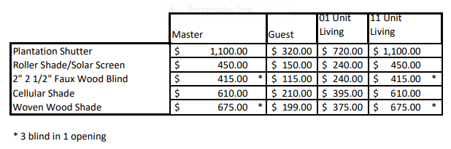

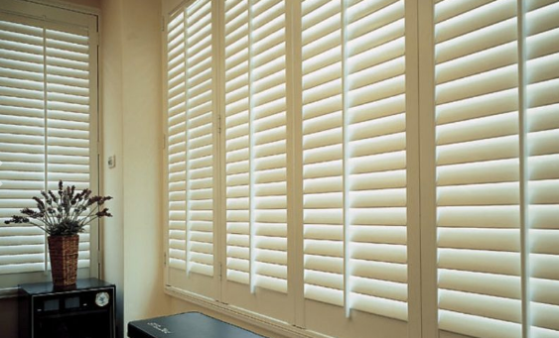

Shutters can transform your home. Our inventory includes elegant premier closed-cell, advanced composite technology, and traditional wood shutters. Choose from a variety of designs and colors to suit your home and your personal style. Not all windows are perfect squares, and we can provide custom fit shutters for arches, ovals, and more while adding privacy. Our well made shutters are very durable and a positive investment in your property that is sure to add value to your home.



Blinds, as a standard household fixture, are simple and affordable. When closed, they serve multiple purposes, privacy, keeping your home cool, and protecting furniture and flooring from the sun’s harmful rays. Your home can be outfitted with stylish, high-quality window coverings at a fraction of the cost other outlets will charge.

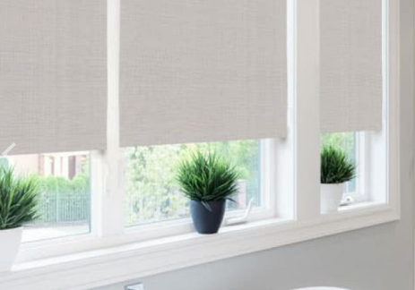

Shades, between roller shades, woven shades, roman shades, motorized shades, black-out or light-filtering shades, solar shades, printed shades, there is no shortage of styles, colors, and features which will outfit your home perfectly.

Damion has over 20 years of experience. He started working for his Dad (in the same business) when he was a teenager. If you aren’t quite sure about what to choose, no worries because Damion and interior designer Cheri will be happy to help you out either in person or remotely. In fact, Cheri is able to design upholstered furniture, comforters and pillows, valences and more to make your home beautifully custom designed.

To schedule a free in-home or virtual consultation with Damion, please give him a call at (386) 301-5180.

Damion Pitts , Owner

Damion, Terrance, and Cheri at Blue Chip Shutters and Blinds are excited to work with Southpoint owners.

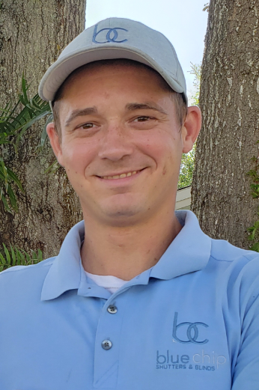 

Terrance, Installer Cheri, Interior Designer

When you see Damion, Terrance, or Cheri at Southpoint, please introduce yourself and say hello!



Let’s meet the Southpoint owners!

Meet Linda Finley, owner of unit 510 since May of 2019.

Linda is a registered nurse who recently retired in July 2019. She has lived in upstate New York all of her life and practiced nursing there for over 40 years.

Her recent position as Hospital Supervisor for 25 years has afforded her the opportunity to attain her life long goal in Nursing Administration. Currently Linda volunteers at the Marine Science Center and at the bird hospital. She finds that the birds have their own unique personalities and is fascinated by them.

Linda isn’t new to the Daytona Beach/Ponce Inlet area. Her sister Sandy and her family have lived in Volusia County for many years and would always visit Ponce Inlet when in town due to its quaintness and relaxed laid back atmosphere. Linda would frequent the nearby restaurant, Racing’s North Turn, and remembers that back in the 1970’s it was known as “Fritzes Ole Timers” place. Linda has been widowed for three years and fondly states that her late husband Michael would have absolutely loved Southpoint Condominiums as much as she does. Linda loves that there is so much to do and visit in the area, or to just simply relax listening to the waves on the beach gives her great pleasure. Her hobbies include walking, bike riding, swimming and kayaking. Linda is very much looking forward to meeting all of the owners at Southpoint!

If you would like to be in the Owner Spotlight, send your story and some information with a picture to: Linda Collette at [redcar@charter.net](mailto:redcar@charter.net)



Owner Kevin Bailey has

created an e-mail list with owners names, unit #, e-mail address, telephone number and rental agency if you rent. If you’d like to be added to this list, please contact Kevin with your information at [kevinbail@bellsouth.net](mailto:kevinbail@bellsouth.net) and he’ll add you.

If you have any newsworthy information you’d like to see here, pictures, etc., please share it with us. You may send any information to Linda Collette via e-mail to: [redcar@charter.net](mailto:redcar@charter.net), and please put “SPC Newsletter” in the subject line. Thank you!

**Southpoint Condominium Association Board of Directors:**

Phil Danley, President - [phil.danley@gmail.com](http://mailto:phil.danley@gmail.com/)

Alan Powell, Vice-President - [adp5721@comcast.net](http://mailto:adp5721@comcast.net/)  
Judy Voiers, Secretary/Treas.  [jvoiers@tampabay.rr.com](http://mailto:jvoiers@tampabay.rr.com/)

Management Company: TJW Management Co, Inc.

Roger Koop, Manager and Maintenance Supervisor, 386-788-4546--[roger.koop@gmail.com](mailto:roger.koop@gmail.com) Karen Stewart - General Manager- kstewart@tjw.net